Latest News on the Clubhouse
The club house extension project is currently on hold for the time being. Planning permission has been granted and the company has moved forward with making preparations so that a start to works could commence relatively quickly. We shall pass on any updates to this as soon as we have them.
Within the Clubhouse itself, there have been some changes to the people we see everyday. Kieran has left the company after many years at the club. We wish him all the best whilst welcoming a new chef to the restaurant with Nicola joining the team. We wish her all the best in that role, and also welcome Megan to the bar and catering team.
The club has appointed an new Assistant Manager to help Richard with the day to day running of the golf club. Joe Lawlor joins the club following 5 years experience working for the PGA directing professional tournaments.
The Simulator Studio is open and information on how to book etc. is available from the Club Shop. This is a state of the art golf simulator and well worth a visit.
The new putting green is now open after several months of nurturing by our green keeping team. We hope you are all pleased with the new addition and are looking forward to improving your short game.
Quiz Nights have been re-introduced this year, following the disruptive previ- ous two years of Covid restrictions and are proving very popular. Please look out for the club house notices and emails to see when the next one is due. It would be appreciated if you could book your teams in well in advance as this will help with the planning of these evenings.
Club news is now available on your club V1 member’s hub and will be updated regularly. We would also like to bring attention to the club social media. Please ensure you are following the clubs twitter and Instagram - @wishawgolfclub

Finally, at the time of writing, we have all just learned of the death of Queen Elizabeth II. I’m sure all our thoughts and condolences go out to the Royal Family at this sad time.

GREAT NEWS FOR WISHAW GOLF CLUB
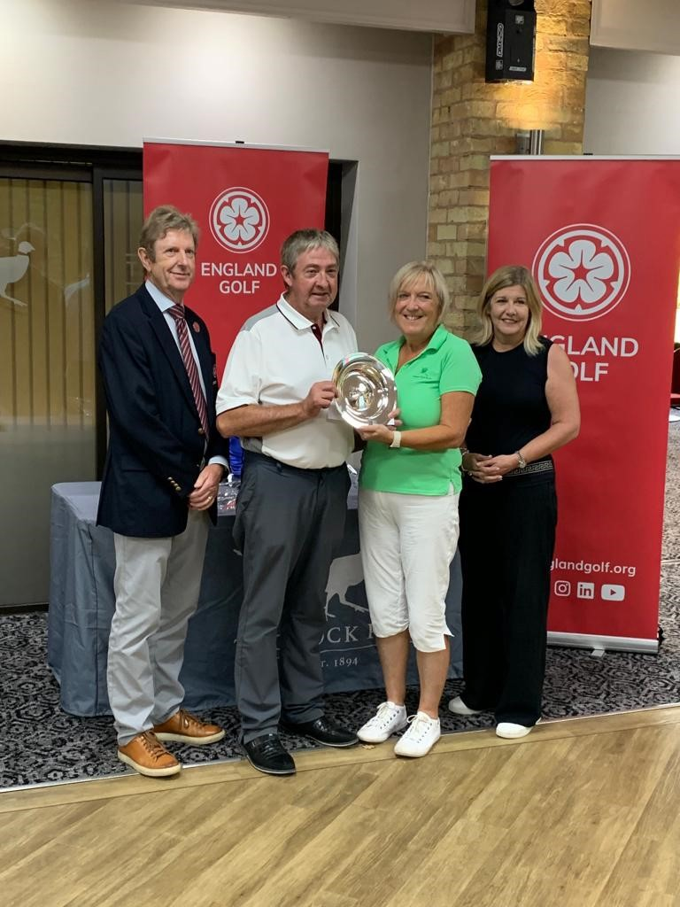
On the 24th July, Wishaw Golf Club held its first Ping 4BBB Mixed Qualifying Competi- tion. Eight pairs took part and the winners, by 5 clear points, scoring a huge 50 points, were Jayne Proud and Craig Harrison. There followed an anxious couple of weeks while they waited to find out if they had qualified for the final. Happily they did and it was held at Thonock Park, the home course of Ping Europe on Tuesday 7th September.
On arrival at the course, they were present- ed with their prizes for qualifying for the event, a Ping golf bag and umbrella each.
Being out fairly early on the day, Jayne and Craig had a good round on a course neither had played before and came in with a very
creditable 45 points. There followed a very intense wait as other scores
came in and they remained leaders in the Clubhouse.
By the end of the day, with what must have been very fraught nerves they were still top of the leaderboard, but there was another 45 in! Happily, Jayne and Craig had the better back nine and had won the event. They were pre- sented with the trophy and a Ping voucher each to the value of £400 along with a crystal fruit bowl as a memento.
Well done to Jayne and Craig on a remarkable achievement.

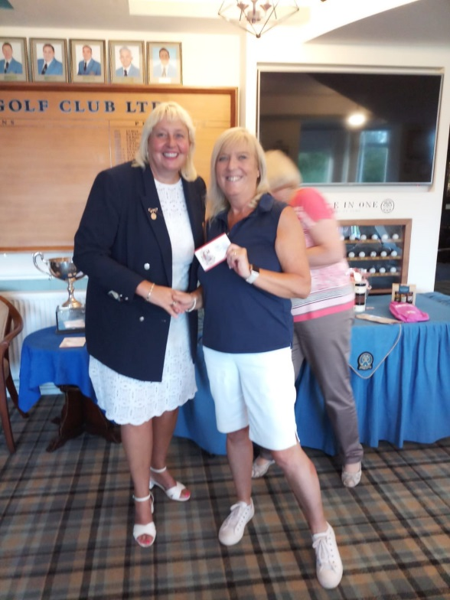
Jayne was back in action again just 2 days later, having qualified at Wishaw for the finals of the Charles Heeley competition at Penn Golf Club. The competition was organised this year by Warwickshire Ladies County Golf Association and was originally set up by Walmley Golf Club in 1925.
Jayne won Division 1, rounding off an excellent
week for her.
Well done Jayne!

CAPTAIN’S COMMENTS

Changes

As the season changes on the course, we should be careful of the wet leaves underfoot and with the changing light, be sure to shout ‘fore’ after any errant shots.

It's also a time when we say thank you to Gemma and Alys who helped with bar duties across the summer, as they now return to college/university. Thanks also to Kieran and Will who have moved on to further their careers - and a warm welcome back to Joe Lawlor who returns with 5 years experience from the PGA, to the new appointment of Wishaw Golf Club Assistant Manager.

Competitions

Congratulations to Jayne Proud and Craig Harrison for winning the Ping Mixed four-ball better ball at Thonock Park. A tremendous achievement both and straight afterwards Jayne carried this fine form into the Charles Heeley Challenge Bowl final at Penn Golf Club. Well done Jayne. Further congratula- tions go to Elaine Pugh and Tony Broome who won Wishaw’s Mixed Foursomes, one of the club’s majors. Also noteworthy is Sue Franklin’s win in the Bridges Bowl, becoming the first lady member to win a major competition open to all Club members.

Once again we host a Seniors Pairs Open, a popular event attracting visitors from many of our neighbouring clubs. This year is no exception and the club welcomes a fully subscribed field on September 21st. Many thanks to Simon and his greenkeeping team who have worked hard to carry out essential work in advance.

On September 24th and 25th there are finalist competitions for the winners of Medal and Stableford competitions during the year. And with the main sea- son winding down the club will soon be taking entries for the Winter Knock- outs.

As always, don’t be afraid to ask in the golf shop if you have any questions. Enjoy your golf everyone.
Paul

PUZZLE PAGE

Iconic holes in golf
Question 1.
Which course is this?
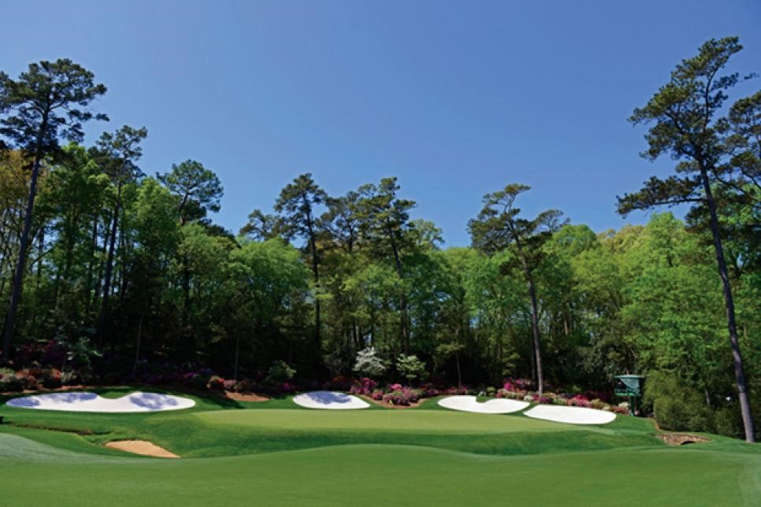
Question 2. Royal Birkdale Golf club is in which English town?
Question 3. You carry a score card with you each time you play which has the names of each hole, so what is hole 13 called?

Now for a few anagrams
Name the famous golfers Question 4. Romance Tsar Question 5. Sweaty parent Question 6. Tennis honckers

Now for some rules questions
Question 7. Are you entitled to free relief from a boundary fence that marks the out-of-bounds line? Yes/No
Question 8. If a players ball rests against the flag stick on the lip of the
cup and some of the ball remains above the cup, is the player deemed to have holed out? Yes/No

Question 9. The 11th, 12th and 13th holes at Augusta National are collec- tively know by what nickname?
Question 10. Which golfer won the 2012 & 2014 US Masters?

A FEW BASIC RULES

Penalty Areas
There are two types of penalty area. Red penalty areas are defined by red stakes or red painted lines and yellow penalty areas defined by yellow stakes or yellow painted lines.

Margin of the penalty area
When defined by stakes – the edge of the penalty area is defined by the line between the outside points of the stakes at ground level.

When defined by painted lines – the edge of the penalty area is the outside edge of the line, and the line itself is in the penalty area.

What is the difference?
The key difference between the two is the options available to the player. With both red and yellow penalty areas the player may play the ball in the penalty area, play another ball from where the last shot was played or take back on line relief, keeping the point the ball last crossed the margin of the penalty area in-between the ball and the hole. For a red penalty area only, the player may also take two club lengths lateral relief no closer to the hole from the point the ball last crossed the margin of the penalty area.

Key points to take away!
Can always play a ball in a penalty area
Can always take back on line relief
Can always go back to where the last shot was played
For red penalty areas only – 2 club lengths lateral relief – no closer to the hole
Reference point for where to take a drop is always the place the ball last crossed the margin of the penalty area.

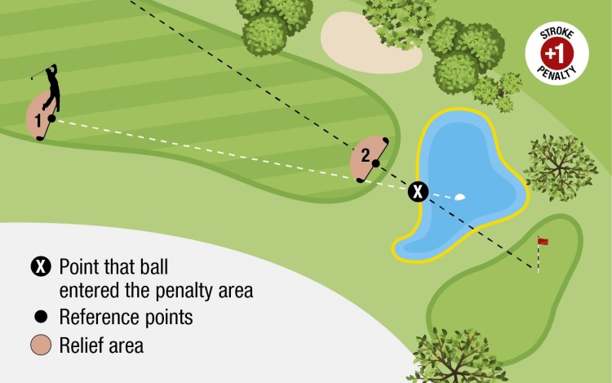
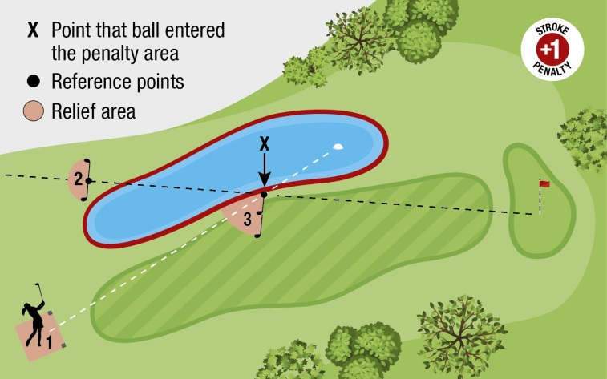

VIEW FROM THE LADIES’ LOCKER ROOM
As the golfing season is coming to a close, the ladies have been extremely successful and can look back with pride to have put Wishaw on the map in numerous competitions.
July was a busy month starting with Captain’s Day. Paul and I were grateful for your sup-
port and the Ladies’ trophy was won by Julia Hodge.
The Charles Heeley qualifier was won by Jayne Proud in the 1st division and 2nd division by Anita Cheung. They both played in the final held at Penn Golf Club in Wolverhampton and I am delighted to congratulate Jayne on winning the 1st division.
The Ping mixed qualifier was won by Craig Harrison and Jayne Proud and they represented Wishaw in the final at Thonock Park Golf Club, Gainsborough and after waiting some time for the result were delighted to be announced as the winners. They came away with new golf bags, umbrellas, fruit bowl and £400 Ping voucher. I congratulate both of them for an outstanding win.
The Ladies Club Championship was won by Victoria Haden and the nett by Jayne Proud, congratulations and well done both.
Obviously, the month of July was definitely a very good month for Jayne.
The month of August was also a good month with Anita Cheung and Kai Yip winning the Ladies Foursomes and they go forward to represent Wishaw in the Daily Mail Foursomes well done to you both.
The Bridges Bowl is a mixed major and again we put the ladies on the map as I was sur-
prised and delighted to be the first lady to win this competition.
We have held our Mixed Foursomes and congratulations go to Anthony Broome and Elaine Pugh as the winners, the runners up were Craig Harrison and Sue Franklin.
Five ladies played in The Warwickshire Union Inter Club Competition at Coventry golf club we came 17th out of 24; not our finest hour but being a medal round we all found it quite tough, thanks to the ladies who played.
I held an away day at The Chase Golf Club where 11 ladies enjoyed the course and the hos- pitality of the club; the overall winner of the day was Kerry Pace.
Besides all of the above the ladies have represented Wishaw in five friendlies since the last news letter and have won four of them. Well done to the ladies who have been a part of the teams. This is a very social side of the ladies and thanks go to Carmel who has organ- ised them over many years.

VIEW FROM THE LADIES’ LOCKER ROOM...continued

We still have our Mad Hatters 3 clubs and a putter to play, and my Vice Captain Lisa Perks is organising an away break at Breadsall Priory so still lots of enjoyable golf to play.
Our course provides a tough game of golf and our slope indicates that. We have a very small ladies’ section and I congratulate all the ladies who have represented Wishaw and have done so extremely well.
Sue Franklin, Ladies’ Captain

ANSWERS TO QUIZ

Answer 1. Augusta National.
Answer 2. Southport.
Answer 3. The Horseshoe. Answer 4. Sam Torrance. Answer 5. Payne Stewart. Answer 6. Henrick Stenson
Answer 7. No, objects defining out-of-bounds, such as walls, fences, stakes and railings are not obstructions and are deemed to be fixed. Thus a player is not entitled to free relief from an obstruction under rule 18.
Answer 8. Yes, If your ball comes to rest against the flag stick left in the hole and any part of the ball is in the hole below the surface of the putting green, the ball is treated as holed.
Answer 9. Amen corner.
Answer 10. Bubba Watson.

SENIOR CAPTAIN’S REPORT
On Wednesday 21st September 2022 the SENIORS PAIRS OPEN COMPETE- TION was played. There were 156 entrants 64 from Wishaw and 92 visitors from various other clubs as far afield as Worcester and Bristol.
For those that do not know there are prizes for the first five pairs, eighteen nearest the pin prizes for the men and three nearest the pin prizes for the la- dies. All nearest the pin prizes are sponsored by Senior Team members except one which is sponsored by Martin Bevan. There were prizes for anyone who scored a “2” and entered the “2s” competition. We had a tombola and a putting competition for anyone who wished to enter.
The day Started at 7.00am with all the volunteers starting their given roles. We had many volunteers, too many to mention. Thank you to them all.
The first tee time was 7.50am and the last tee time was 2.10pm making it a long day.
The result was
1st T. Hanson/P. Doughty Darnford/Branston 49 points 2nd A. Fox/P. Spencer Wishaw/Wishaw 45 points 3rd W. O’Reilly/W. Felles Wishaw/Wishaw 45 points 4th G. Poulton/S. Poulton Wishaw/Visitor 44 points 5th M. Rogers/D. Green Wishaw/Wishaw 44 points.
The day was successful because of the hard work of Geoff Greenwood, assist- ed by Richard Massey and many volunteers. Richard Langley and Joe checking the scores and entering them on to “How Did I Do”. Thank you as always to the kitchen staff.
There are just two games left for the Seniors before the season finishes. The first is the 6th round of Senior Player of The Year, being played on the 29th September at Ullesthorpe. The second is at Mickleover and is our final inter club match for this year being played on 4th October.

FINAL NOTE FROM THE EDITOR
Apologies for not including the full Majors’ results in this edition but due to a holiday commitment, there was no time to get these done accurately in time for the publication deadline. There will be a full report on these in the next issue.
Again, it is hoped that you find your Club Newsletter interesting and informa- tive and all comments or suggestions for articles would be welcomed. Please contact secretary@wishawgc.co.uk

